Project Design Phase-II
Data Flow Diagram & User Stories
Date | 31 January 2025
Team ID | SWTID-2026-6425
Project Name | EduGenie – AI-Powered Learning Assistant
Maximum Marks | 4 Marks

Data Flow Diagrams:
The DFD shows how a student's learning request enters EduGenie, is processed by the FastAPI application and feature modules, reaches the Gemini service, and returns a learning result to the web interface.
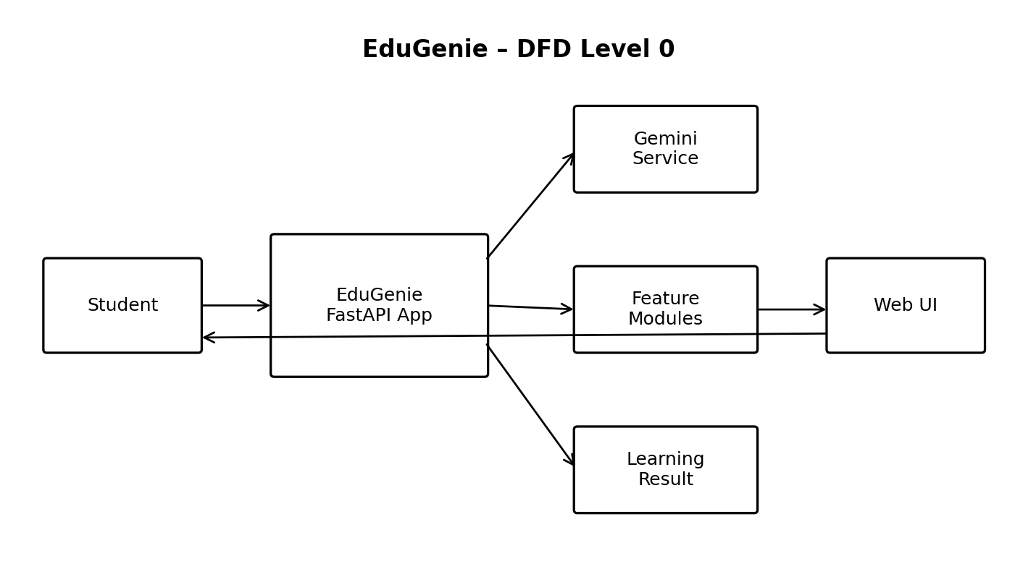
User Stories
Use the below template to list the user stories for EduGenie.
User Type | Functional Requirement (Epic) | User Story Number | User Story / Task | Acceptance criteria | Priority | Release
Customer (Web user) | Question Answering | USN-1 | As a user, I can ask a question and receive an AI-generated answer. | An answer is displayed for a valid question. | High | Sprint-1
Customer (Web user) | Topic Explanation | USN-2 | As a user, I can enter a topic and receive an explanation. | A topic explanation is displayed. | High | Sprint-1
Customer (Web user) | Quiz Generation | USN-3 | As a user, I can generate a three-question quiz from a topic. | Exactly three questions with four options, correct answers and explanations are shown. | High | Sprint-1
Customer (Web user) | Text Summarization | USN-4 | As a user, I can submit text and receive a concise summary. | A summary is returned for valid text. | High | Sprint-2
Customer (Web user) | Learning Path | USN-5 | As a user, I can request a learning path for a topic and learner level. | Stages, concepts, timeline, practice/projects, resources and milestones are returned. | High | Sprint-2
Customer (Web user) | Health & Error Handling | USN-6 | As a user, I can receive a controlled response when the AI service is unavailable. | The application reports an appropriate service error instead of failing silently. | Medium | Sprint-2

